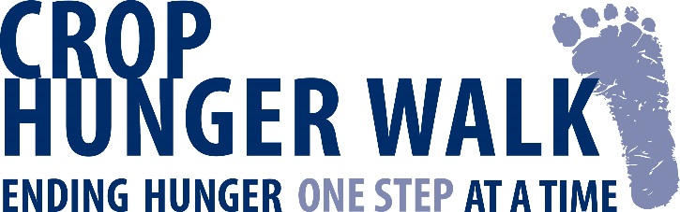

Add Walk name. CROP Hunger Walk
WHAT is the CROP Hunger Walk?

WHEN?

WHERE?

WHO gets
the money?

WHO is helped?

WHO should
participate?

COST?

QUESTIONS?
Each year, our community comes together to raise money and awareness for hunger relief locally and around the world through the CROP Hunger Walk. Roughly 1,000 CROP Hunger Walks happen every year in the United States. Walkers ask family, neighbors, colleagues and places of worship to pledge dollars for their participation in a Add Walk distance. walk. Our steps symbolize the daily journey others must make for food and clean water.

The Type Walk name. CROP Hunger Walk will be held on Click or tap to enter a date. beginning at Add Walk time.. (Registration begins at Add registration time.).

Add walk location, including address.

One-fourth of the funds raised stays in our community to support local hunger and poverty fighting programs. This year’s walk will support the work of Add local agency names.. The remaining money is used by Church World Service to alleviate hunger in poor communities throughout the world.

In addition to assisting hungry families in our area, CROP helps families in the United States and around the world who are victims of disasters like Hurricane Sandy, the earthquake in Haiti, and refugees fleeing war or famine. CROP also supports development projects in the world’s poorest communities - agricultural training, health clinics, micro-businesses, schools, and fresh water wells.

EVERYONE! CROP Hunger Walks are community events involving everyone who wants to fight hunger around the block and around the world. Our walk encourages teams and individuals from public and private schools, civic and cultural groups, area businesses, and all faith groups.

There is NO FEE to participate. All donations are helpful, but each walker is encouraged to raise $100 or more.

For more information, contact type contact information

