WALK DATE
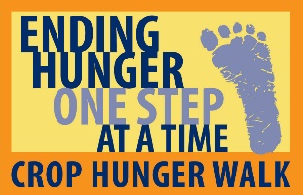
STUDENTS NEEDED TO JOIN OUR MOVEMENT TO END HUNGER!

(LOCAL WALK NAME)

As a student, you can have a real impact on hunger. Join the <<insert walk name>> CROP Hunger Walk on <<date>> to take your first steps.
CROP Hunger Walks were the first charity walk in our nation and remain a grassroots effort symbolizing the daily journey that many must make for their basic needs. Hunger is everywhere—even in your own neighborhood. A quarter of all funds raised stays in your local community, and 75% supports sustainable hunger responses around the world.
CROP Hunger Walks support the work of CWS, founded 70 years ago by faith groups at the end of WWII, to battle domestic and international food shortages. CWS has built a strong network of support with secular and interfaith partners, including locally through food banks and globally with the United Nations. CWS works with CROP Hunger Walkers to empower people around the world through gardens, tech training, year-round clean water, and support to reach their potential.
Get Involved! You can reduce hunger and poverty through your advocacy for social justice and through your actions to educate and mobilize others to walk. Serving on the team can take as little as an hour or can grow depending on how much time you want to invest in this mission to end hunger!

Actions you can take:
- Walk - in solidarity with others, your physical activity shows you care. (2-3 hours)
- Educate - hunger is a local and global problem. Learn, then share with others. (as little as 1 hour)
- Fundraise - make a difference by asking for donations to provide food and water. (as little as 1 hour)
- Volunteer – recruit a team from your school (as little as 1hour), serve on the planning team (4-6 hours), help on walk day (2-4 hours).
- Create - Use your talents in art, speaking, acting, music to create videos, memes, skits, etc. (2 hours)
CROP Hunger Walks can impact YOUR life!
- Connect to likeminded students and faculty
- Community service hours for school (all opportunities above can be expanded for more hours)
- Leadership, networking and learning opportunities
- Deepen your understanding of poverty in our world (a life skill)
- Great content for your college application/resume
For more information about how to get involved, visit WALK URL or contact your local
CROP Hunger Walk committee at EMAIL ADDRESS

Volunteer Hour Documentation
Have a CROP Hunger Walk Committee member sign your school forms or provide verification of your service hours here:
Student Name: __________________________________________ Hours earned: _____________
CROP Team Member signature:______________________________ Date:_____________________

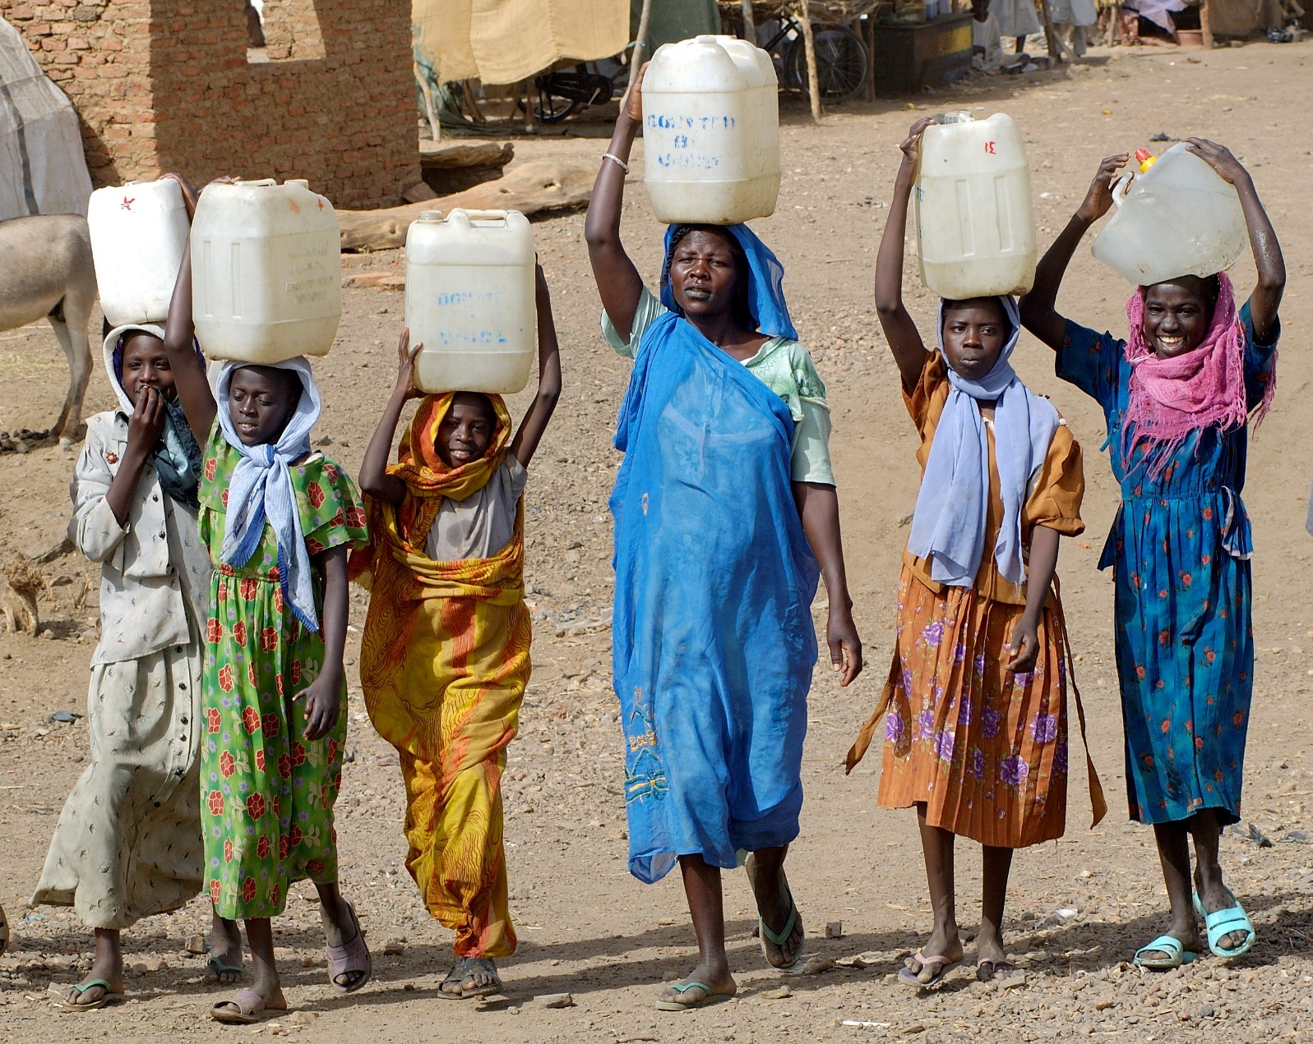

Certificate of Appreciation to:
___________________________________________
(Student name)
On behalf of the CROP Hunger Walk
In honor of the _____hours of community service performed in service of the hungry.
__________________________________________________________________________
(list of activities and duties performed)
On ______________________________________ _______________________________________
(date(s) of service) CROP Hunger Walk Coordinator

