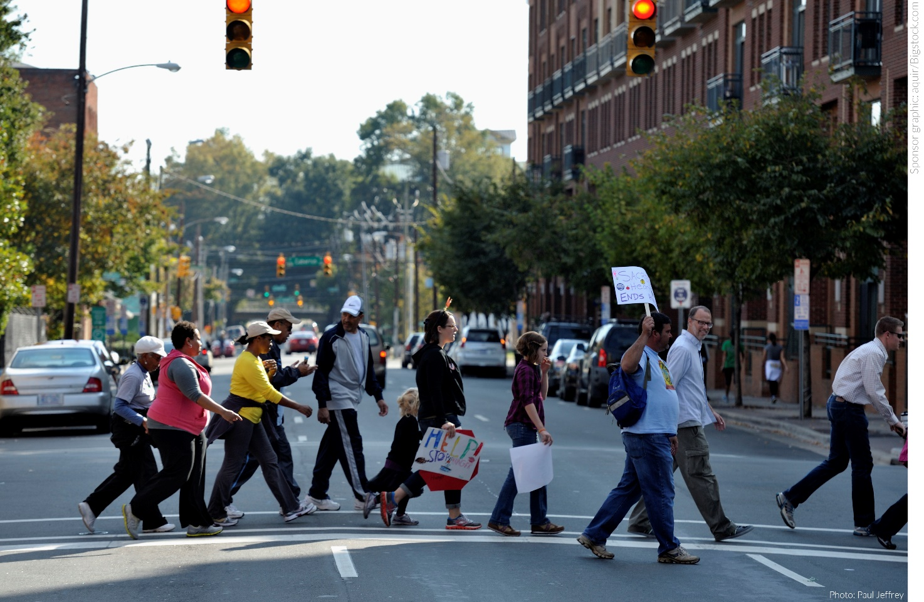

**[Walk Name] CROP Hunger Walk**

[Date]

[Location]

 