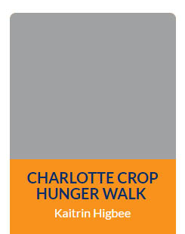
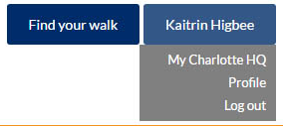
Log in to your HQ
Your HQ is the perfect place to check on your fundraising progress, send emails to friends and family, share with others on social media, and so much more! Here’s how you get there:
Log in to www.crophungerwalk.org and click on the box that has your Walk’s name. That will take you to your personal page. Then hover over your name in the top right corner, and click “My … HQ”.
Send email to friends and family
Email is a great way to involve others in your Walk – whether near or far. Invite them to join or support you online – quickly and securely. Log in to your HQ to get started.
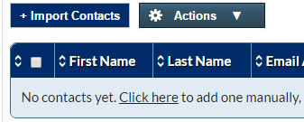
Adding and managing your contacts
Adding one at a time: Click “Import Your Contacts” in the right column. Then click the down arrow on the “Actions” button, and select “Add Contacts” from the drop-down list. In the pop up box, enter the contact’s name, email, and a greeting that can be used in your message. Then click “Add”. You can continue adding as many contacts as you want, and click the “x” when you are finished.
Import from your email: You can also import your contacts from your Gmail, Yahoo or other account. From the main HQ page, click the same “Import Your Contacts” link, then click “+ Import Contacts”, and choose your email client. Follow the instructions provided for your email client.
Removing contacts: To delete people from your contact book, simply click the box next to their name, go up to “Actions”, click the down arrow and click “delete”. You will be asked to confirm via pop up box.
Sending email messages
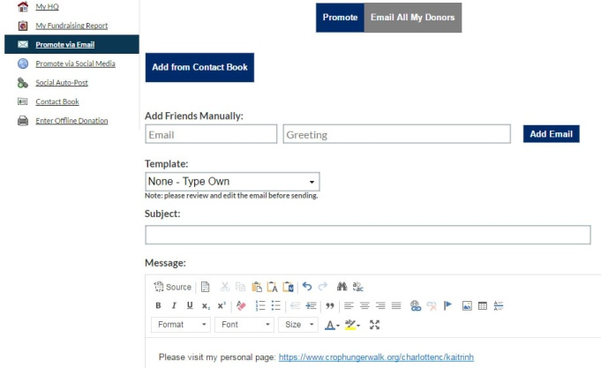
Log in to your HQ, click the “Promote via Email” link on the left column, and you’ll see the message composer. You can add email addresses manually, or click “Add from Contact Book” and check the boxes next to the contacts who should receive the message. Note: The system will send to a maximum of 20 email addresses at a time, so do not select or enter more than 20 recipients.
You can create your own message, or start with a pre-built template using the “Template” drop-down list. After customizing your message, you can simply send it right out, or save it as a new template for use in the future (helpful if you’re sending the same message to a large group of contacts).
This is important! For security reasons, you are required to verify your email address before sending email through the system. You will receive an email asking you to verify your account by clicking a special link. Simply click that link and you’ll be good to go.

Spread the word on social media
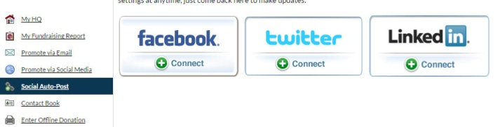
You can connect to your Facebook, Twitter and LinkedIn accounts in your HQ. In the right column of your HQ, click “Connect to your Social Networks”. Click the “Connect” button for the account you’d like to link up and you will be prompted to log in to that account.
Setting up automatic social posts
Once you’ve logged in to that account, you can choose what types of posts (if any) you would like www.crophungerwalk.org to automatically post to your Social Network account. Auto-posts can trigger when you receive a donation, update your goal and/or update your personal page.
Want to make a change to these settings? It’s easy to do. Go back to the “Social Auto-Post” link in the left column of your HQ and you’ll see any accounts you have connected. You can click or unclick the boxes beneath Auto Share to choose which types of posts you would like to share, and click “Save Settings”. If you want to disconnect a Social Network, simply click the “x” next to the Social Network that you want to disconnect.
Manually sharing via social media
If you’d prefer to manage social media posting on your own, your HQ can help you with that, too. Click the “Promote via Social Media” link in the left column of your HQ and select the account you’d like to share from. The relevant message fields will appear below the icons with starter content, which you can customize as you like, then connect with your account to send.

Thank you! You are helping to end hunger one step at a time – in your community and around the world!

