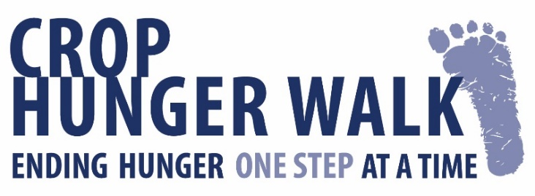

Email Template

Personalize and send the message below using your own email.
To find the URL link to your personal fundraising page, log into your fundraising page, highlight the web address in the box at the top, cut and paste into the message below.

Dear Friend,
No one in this world should ever go hungry. That's why the CROP Hunger Walk is so much more than just an event for me – it’s my chance to take real action against hunger.
By walking, I’m helping families who face the heartbreaking reality of not knowing where their next meal will come from. I’m walking to make sure that one more person has enough to eat. I want to help as many people as I can in my community and around the world and I need your support to make that happen.
The steps we take - and the funds we raise - support programs that provide meals and other immediate support, as well as long-lasting solutions to hunger.
Please join me in the fight against hunger by donating to my Walk today!
(Insert the URL link to YOUR fundraising page here)

Thank you for sharing your compassion and generosity!

Your Name

