
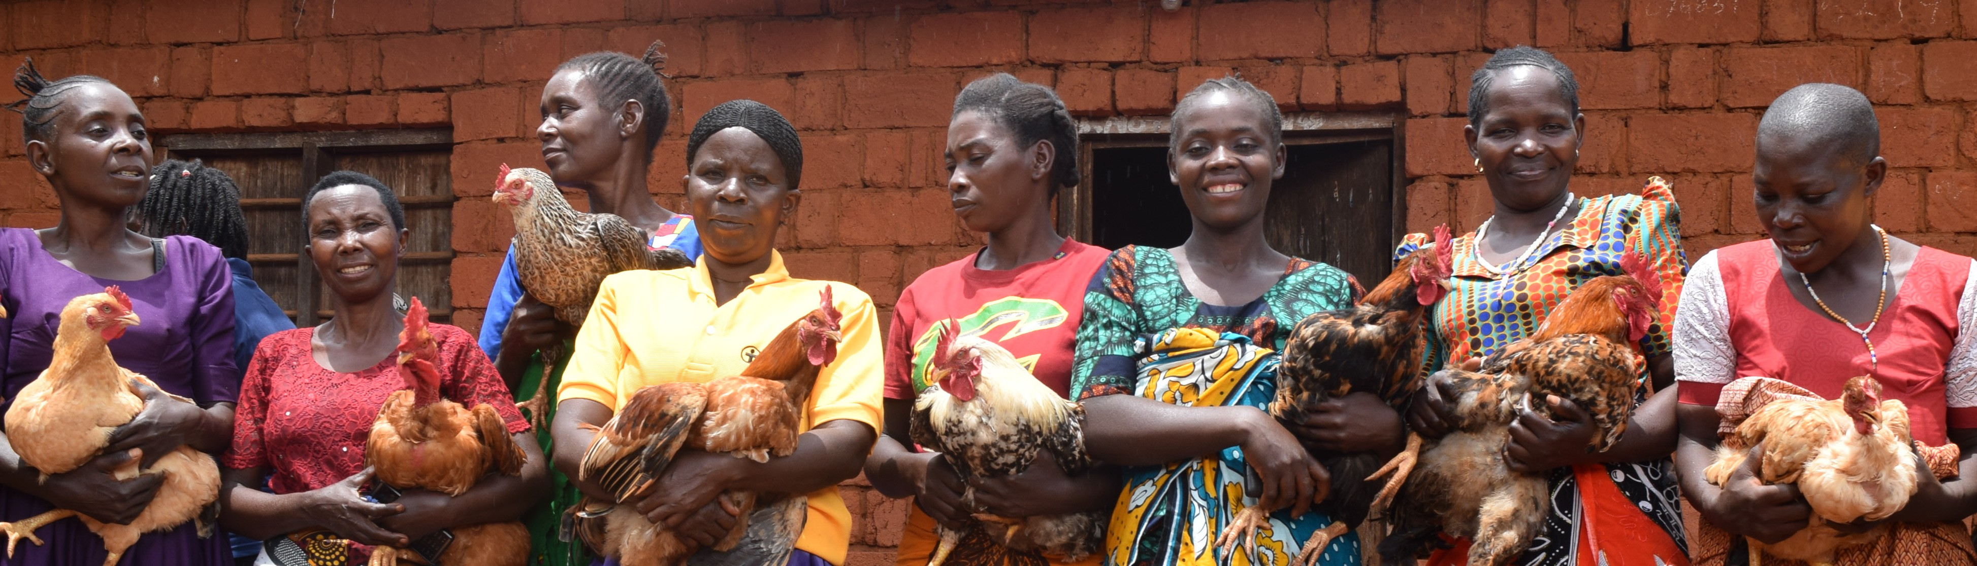

For being an incredible [TEAM CAPTAIN] at the
[WALK NAME] CROP Hunger Walk.
We appreciate you!
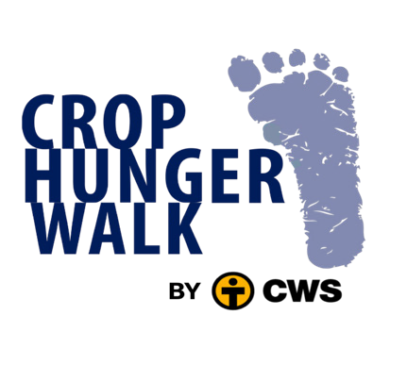
CWS [Associate] Community Engagement Specialist

