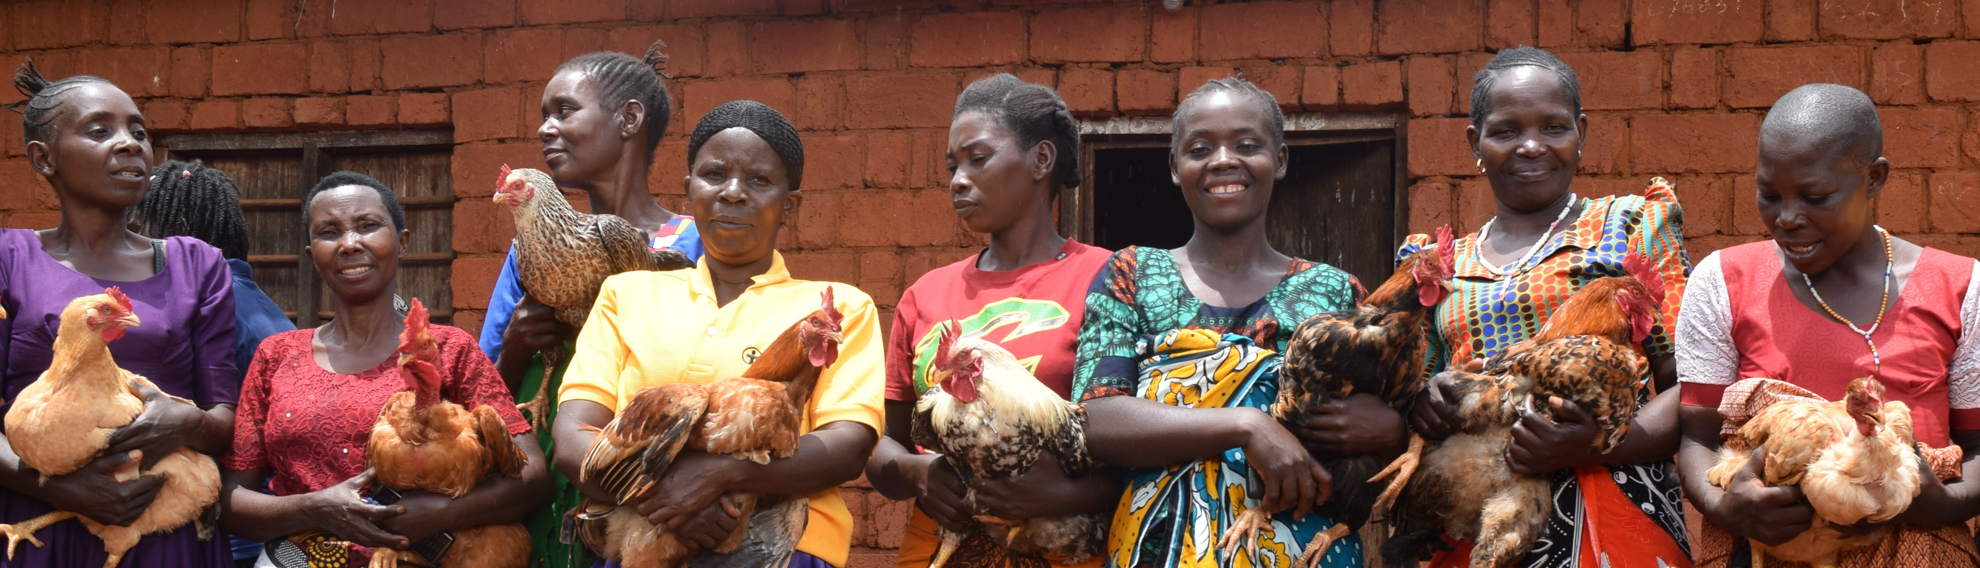

For being an incredible [TEAM CAPTAIN] at the

[WALK NAME] CROP Hunger Walk.

We appreciate you!



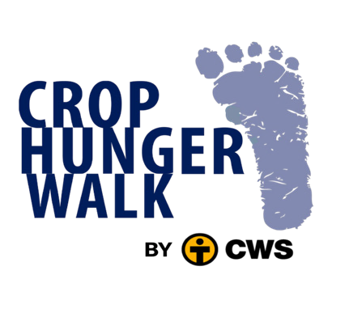

**CWS [Associate] Community Engagement Specialist**