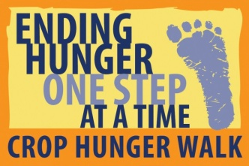 Local Hunger Agency Memorandum of Understanding

CROP Hunger Walk is a fundraiser that also raises awareness of hunger not only globally but also in the communities hosting the walks. Walk teams can request up to 25% of the funds raised to be allocated as a grant to assist with local hunger needs.

Local hunger fighting agencies are selected for these grants by the Walk Planning Team based on the agency’s impact on local hunger and willingness to actively participate in the planning and promotion of the walk event.

All local grant recipient agencies are expected to do the following:
- Encourage their Board Members, volunteers and clients to have a walk team
- Promote the CROP Hunger Walk on their agency website
- Send out save the date emails for the walk, the rally and any other gatherings
- Include the walk in their agency newsletters and e-blasts
- Provide agency information for use in publicizing the need and impact locally
- Provide a meeting space when needed – committee meeting, rally, clergy gathering, post walk evaluation, etc.
- Display walk poster and information in visible locations at the agency
- Promote volunteer needs for walk day

Agencies will choose one or more of the following to also do in support (Please check your preference. Assignments will be given out based on the order in which forms are returned):

_________ Secure snacks for the walk day
_________ Provide volunteers to oversee registration on walk day
_________ Organize the water stops and staff with volunteers for walk day
_________ Help on Walk day to facilitate hunger education simulations/activities
_________ Supply a Communications Coordinator for the team to take minutes at the meetings and send out follow-up emails and reminders to team members

We understand that in order to receive funds from the CROP Hunger Walk our agency must ACTIVELY participate in the promotion of the event.

Local Agency name: _________________________________________________________

Signature of person completing this form: _______________________________________

Printed name and title: _______________________________________________________

Date: ___________________________

Please return to: _____- by _____

