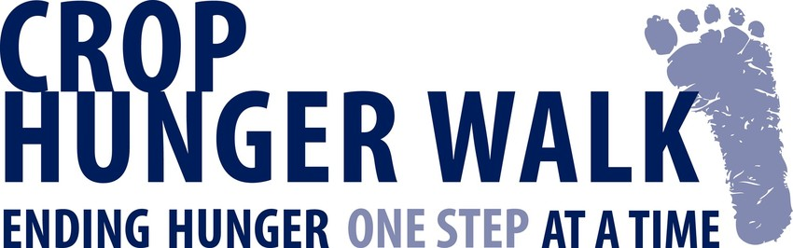

Sample Press Releases

News Release (Please edit/modify with local info as appropriate)

[Name of WALK and/or community] CROP Hunger Walk -- helping end hunger one step at a time
Contact: [name]
[address]
[phone, fax, and/or e-mail]

FOR IMMEDIATE RELEASE
[Name of Walk and/or community] CROP Hunger Walk to be held on [date].

Looking to make a difference in our local community and in communities worldwide, the [Name of Walk and/or community] CROP Hunger Walk has set a goal of [number] Walkers and hopes to raise $ to help end hunger and poverty through long-term sustainable approaches to significantly reduce or eliminate hunger. A portion of the funds raised here in will go to the [e.g. hunger-fighting work or food pantry] of [name of local agency(ies)].

Last year, [number of Walkers] Walkers raised more than $ through this CROP Hunger Walk.

This year [name of community] and some 1,000 other communities nationwide are joining together in interfaith CROP Hunger Walks around the theme "Ending hunger one step at a time." Many of the Walkers will be wearing t-shirts proclaiming their solidarity with the millions of neighbors around the world who have to walk to live -- as well as with the millions served by local food pantries, food banks and meal sites here in the U.S. These local ministries share in the funds raised by CROP Hunger Walks.

From combating droughts in Nicaragua to providing agricultural training in Indonesia to stocking shelves in hundreds of food pantries across the United States, CROP Hunger Walks are fighting hunger.

or….

News Release (Please edit/modify with local info as appropriate)
[Name of WALK and/or community] CROP Hunger Walk -- helping end hunger one step at a time
Contact: [name]
[address]
[phone, fax, and/or e-mail]

FOR IMMEDIATE RELEASE

[Name of Walk and/or community] CROP Hunger Walk to be held on [date].

[Name of Walk and/or community] joins communities across the United States to help end hunger one step at a time, both around the corner and around the globe. CROP Hunger Walks support the international relief and development work of Church World Service. Additionally, the [Name of Walk and/or community] CROP Hunger Walk will support the efforts of [name of local agency(ies)] to eradicate hunger in our community.

Join us on [Recruiter Rally Date] at [Recruiter Rally time] at [Recruiter Rally location] for our Recruiter Rally, which is a time for organizational representatives and team captains to pick up materials, exchange information and strategies for increasing engagement and learn more about the work that the CROP Hunger Walk supports.

CROP Hunger Walks are making a big difference worldwide, including ensuring that more children reach their 5th birthday, teaching sustainable ways to grow food and providing additional sources of food and income to families facing extreme challenges. We hope that you will join us in helping to end hunger!

For more information about the [Name of Walk and/or community] CROP Hunger Walk, contact [contact information].

or...

2017 CROP Hunger Walk
THE HEART AND ‘SOLE’ OF <City> MARKS <#> YEARS

MEDIA CONTACTS:
Walk Coordinator:
Phone:
Email:
Church World Service Staff:
Title:
Phone:
Email:

City, State - The CROP Hunger Walk is the heart and "sole" of <City>. It is the only event that brings together all members of our community - young and old, all faiths and walks of life for a common goal - to end hunger, one step at a time! This year gather a team and help mark the <#> anniversary of the <WALK NAME> CROP Hunger Walk.

The 2017 CROP Hunger Walk will take place on <DATE> at <TIME> at <LOCATION and ADDRESS> in <CITY>. Registration starts at <TIME>. and step-off is at <TIME>.

The 2017 local benefitting agencies are:
- Church World Service
- <LOCAL AGENCIES>
Sponsors, Friends and Partners for the <WALK NAME> CROP Hunger Walk include: Church World Service, <LIST SPONSORS>.
CROP Hunger Walks help children and families worldwide - and right here in <LOCAL CITY>- to have food for today, while building for a better tomorrow. Local efforts are making a huge difference, and so can you.
Learn more about the cause at www.crophungerwalk.org

